# User Research

1. Astra

Last Updated 23 Jul 2024

|

[Blog](https://wpastra.com/blog/) » [Review](https://wpastra.com/review/)

**Hummingbird Plugin Review 2025: Is This Caching Plugin Any Good?**

**Quick Summary**Hummingbird Performance by WPMU DEV is a caching plugin for WordPress. This review covers setup, features like uptime monitoring, and optimal use to speed up your website. Read ot to discover why we recommend Hummingbird to enhance website performance through efficient caching.



In this post, we’ll be taking a look at the [Hummingbird](https://wpastra.com/go/hummingbird/)Performance plugin by WPMU DEV. Reviewing the features available in both the free and Pro versions, what the plugin offers, and how to set it up optimally for your WordPress website.

Let’s get started!

**What is Hummingbird Performance?**

Hummingbird is an all-in-one caching and optimization plugin by the WPMU DEV team. While the plugin itself may be reasonably new to the market, it’s development team certainly isn’t.

Launched initially as a Multisite Website development agency, WPMU DEV turned into a [WordPress Multisite plugin](https://wpastra.com/plugins/wordpress-multisite-plugins/) company. Which has ultimately ended up as an all in one tool for your website. Offering everything from caching, SEO, backups, and, most recently, even hosting.

The [free version of Hummingbird](https://wordpress.org/plugins/hummingbird-performance/)powers over 90,000 websites and has over 500+ five star reviews on WordPress.org.

**Hummingbird in Action**

Let’s be honest, the real reason anyone uses a plugin like Hummingbird is to speed up their website, right?

So we set up a test website and first ran a speed test without Hummingbird installed. We then installed Hummingbird (the free version) and ran a speed test. Then ultimately, we installed the paid (Pro) version and ran a speed test.

Before we get into the juicy part (the results), first, here’s a little bit about our testing environment.

A bit about the test website. It’s set up using PHP 7.3 on a Linode server with WordPress 5.3.

The theme I’m using for these tests is our very own Astra, a blazingly fast lightweight WordPress theme. And I’m also using one of our Astra starter site templates allowing you to build a full site in minutes.

Without further ado, let’s check out the results.

**Without Hummingbird**

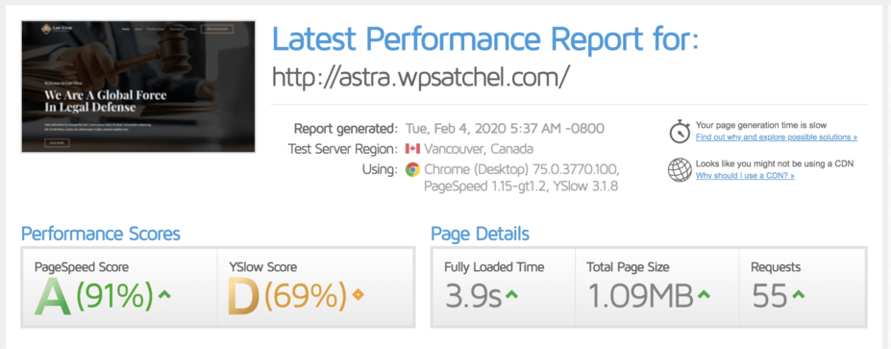

A full-page load time is 3.9 seconds, a total page size of just over 1MB and 55 total requests. Not that bad! But let’s now try with Hummingbird free.

**With Hummingbird**

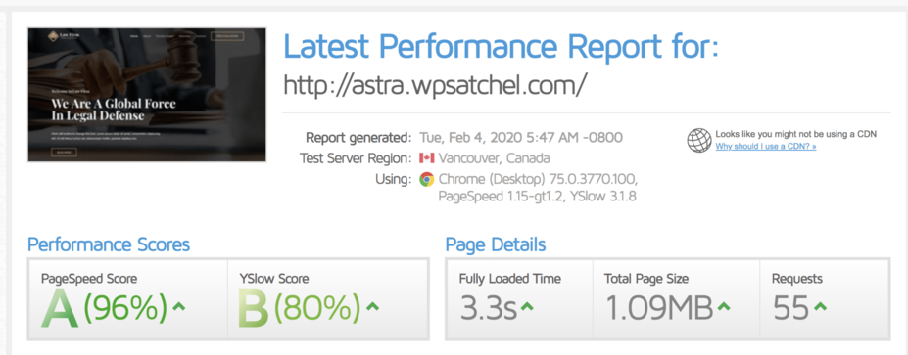

A full-page load time of 3.3 seconds, a total page size of just over 1MB, and 55 requests. A rather impressive result! We’ve shaved a decent bit off our load time, and this was with a very basic configuration.

**How to Use Hummingbird to Speed up Your Website Quickly**

You’ve seen how we got impressive results with Hummingbird above. In the next section, we’re going to show you in 5 easy steps how to do the same on your website.

**Step 1: Install the Plugin**

There are a couple of ways you can install Hummingbird depending on if you’re using the free version or the Pro version.

If you’re using the free version, you can install it via your*wp-admin > plugins > add new*and search for “**Hummingbird**.”

Whereas if you’re using the Pro version, you can use WPMU DEV’s Site Hub. Site Hub is an all-in-one website management interface that makes it easy to manage updates and the installation of plugins/themes from one unified interface.

Here’s the interface in action:

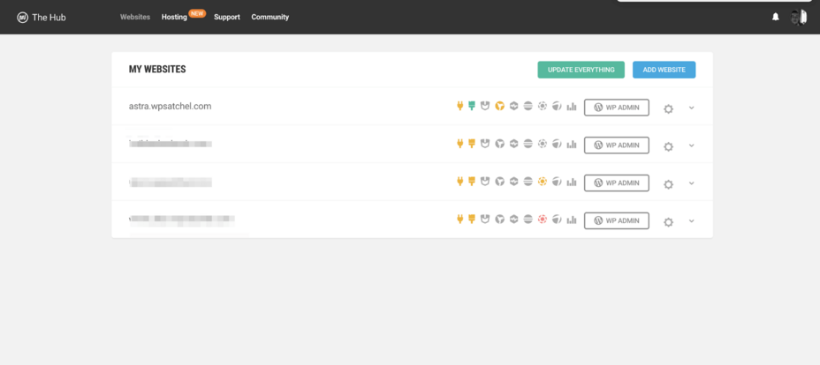

**Step 2: Configure Caching**

In your *wp-admin > Hummingbird > Caching*, enable the caching module:

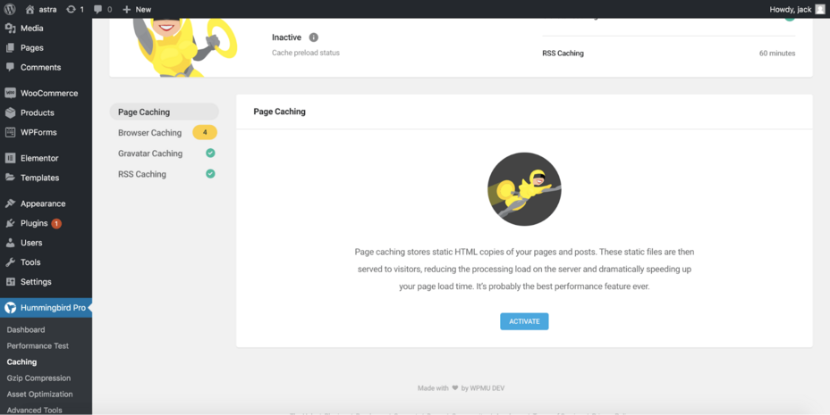

Once enabled, you’ll be able to set a variety of settings:

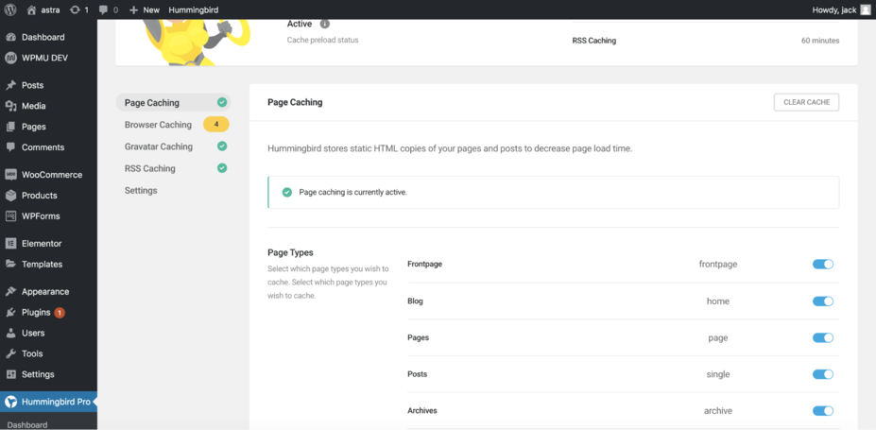

Just some of the settings available include:

* Cache preload — preload the cache rather than waiting for visitors to visit the front-end of your site to generate the cache.
* Mobile caching — whether you want to enable caching for mobile users or not.
* Exclusions — multiple options allowing you to exclude various cookies, pages, and URLs to prevent conflicts with dynamic plugins such as [Membership Plugin](https://wpastra.com/plugins/wordpress-membership-plugins/) and WooCommerce.

You can also independently set which pages and posts you want, or do not want cached with easy to use toggle switches.

There are, of course, also many more options available, all of which are [documented over in the official Hummingbird documentation](https://premium.wpmudev.org/docs/wpmu-dev-plugins/hummingbird/).

Enable page caching, and leave it at that for this part. You only need to configure other aspects if you wish. Once you’re happy with the configuration, scroll down, and click “**Save Settings**.”

**Step 3: Combine and Minify Your Files**

Minifying and combining files is a critical process to ensure your site loads faster. As you’d expect from any decent optimization plugin Hummingbird comes with all this built-in.

Head on over to your *wp-admin > Hummingbird > Asset Optimization*. The first thing you’ll need to do is enable the module, and then Hummingbird will run a scan to find all the files that can be optimized:

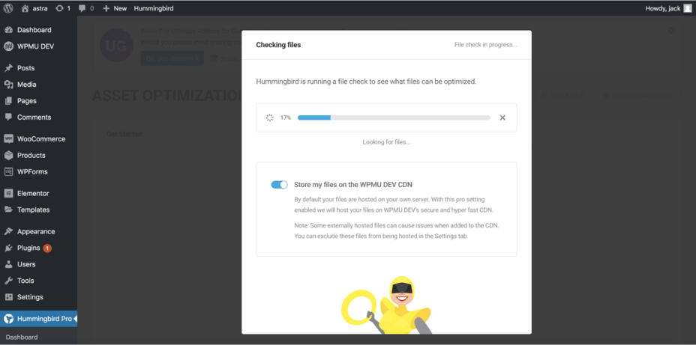

Once the scan has completed you’ll see a message that displays how many files you have:

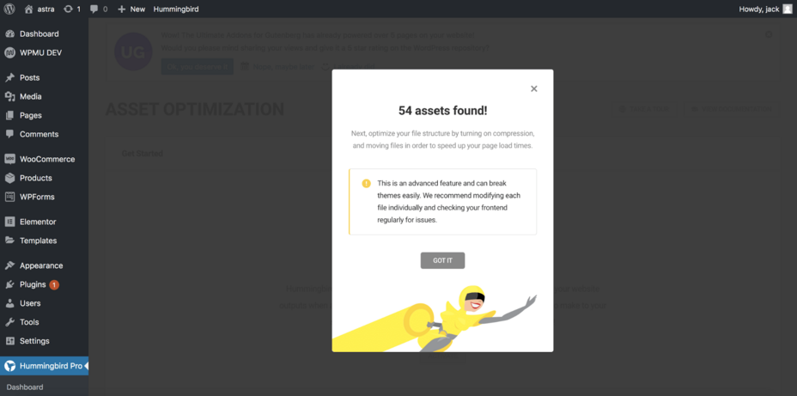

Once that’s complete you’ll then see the Asset Optimization primary settings screen like so:

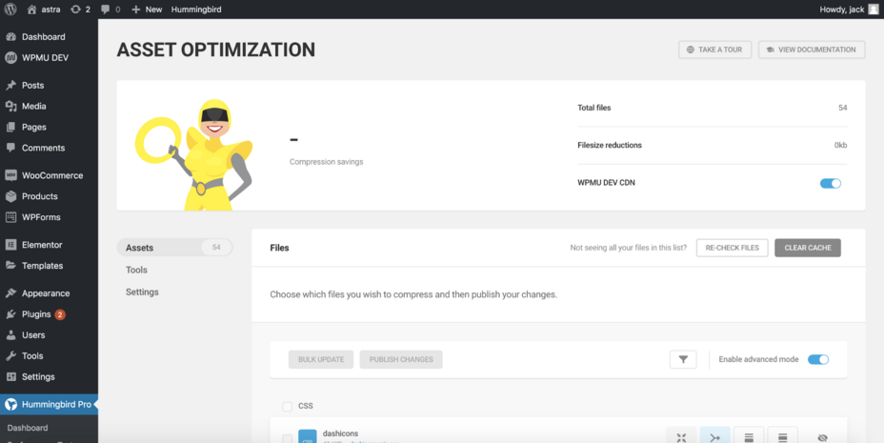

Here you can see the total number of files, the overall reduction in Filesize. If you are using [Hummingbird Pro](https://wpastra.com/go/hummingbird-pro/), you’ll be able to enable the WPMU DEV CDN.

Want to learn what a CDN is and find out what the best CDNs are? Check out our [in-depth article here.](https://wpastra.com/resources/top-cdn-providers/)

Scroll further down the page, and there’s a list of your website’s assets.

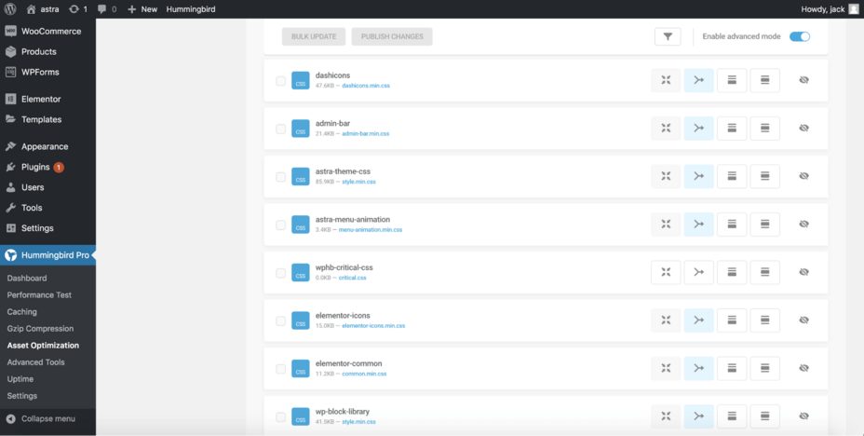

In total, there are 5 different icons; working from left to right they are:

* Minify — Reduce the file size of the mentioned file. If the file is already minified, this option won’t be clickable.
* Combine — Also known as concatenation, is when you combine all CSS files into one CSS file and all JS files into one JS file. This reduces the number of requests sent to the browser and thus improves load times.
* Move to footer — Moves the script to the footer to help fix the “Prevent [render-blocking Javascript](https://wpastra.com/guides-and-tutorials/fixing-render-blocking-javascript/)” and “Prevent render-blocking CSS” errors.
* Inline CSS — Moves the CSS from the specified file to be inline (within the page source).
* Don’t load file — Prevents the specified file from loading at all. Useful if you don’t need the script on your website.

While you can bulk apply rules such as combining all scripts. We would strongly recommend taking the following steps:

**Step 1: Combine Scripts**

Scroll through the scripts displayed and combine each script one by one and save your changes. Once you’ve combined a script and saved your changes, visit the front-end of your site and check for any issues.

If there aren’t any issues, proceed to combine the next script and save your changes. Repeat this until you’ve combined every script which will reduce the number of total requests sent to the browser.

**Step 2: Minify Scripts**

Similar to what we’ve just done with combining scripts, you also want to minify scripts to ensure the files are the smallest size possible. Go through and minify each one and save your changes, checking the front-end of your site for any display issues.

Many plugins and themes already do this out of the box, and if that’s the case on your website, you won’t be able to minify those scripts. Again as there’s no need and Hummingbird automatically detects minified scripts as we mentioned earlier.

Once you’ve gone through and set that up, your website should now be blazing fast.

**Hummingbird Pricing**

Unlike most other plugins that we review here at Astra, the pricing of Hummingbird is a little different.

You can’t purchase Hummingbird on its own. Instead, you have to [buy a WPMU DEV membership](https://wpastra.com/go/hummingbird-pro/)that is free for 30 days and then $49/month:



But what exactly does it entail?

* Web hosting for 3 sites.
* Unlimited WordPress support for any WordPress issue.
* Smartcrawl Pro — A full-featured SEO plugin.
* Forminator Pro — A fully-featured form plugin with integrations with payment gateways, marketing tools like Mailchimp, and much more!
* Defender Pro — All-in-one security plugin to protect your WordPress site.
* Snapshot Pro — Backup and restore your WordPress site in a few clicks.
* Hummingbird Pro — Make your website blazing fast with this caching and optimization plugin.
* Smush Pro — Compress your images and speed up your website hosting your images on the WPMU DEV CDN.

All plugins can be used on an unlimited number of websites. If you ask us, it’s a great value! But it’s more expensive than other [caching plugins](https://wpastra.com/plugins/best-wordpress-caching-plugins/) like WP Rocket if you just want a caching plugin and nothing else.

Or, of course, you can always use the free version of [Hummingbird](https://wordpress.org/plugins/hummingbird-performance/)if you don’t want to upgrade to the Pro version.

**Hummingbird Pro features**

By now, you might be thinking, “well what feature does Hummingbird offer?” Turns out quite a lot!

At first, it may even be a little overwhelming considering the vast array of features offered. However, the user experience is well thought-out with plenty of documentation to assist as well.

* Performance report.
* Browser Caching
* Full-Page Caching
* Gravatar Caching
* Uptime Monitoring
* Cloudflare Cache-Control
* Gzip Compression
* Asset Optimization
* Hosted File Optimization (CDN)
* Database Optimization
* Cache Preloading
* Easy and Advanced Modes

Here are some highlights of our favorite features of Hummingbird

**Performance Reports**

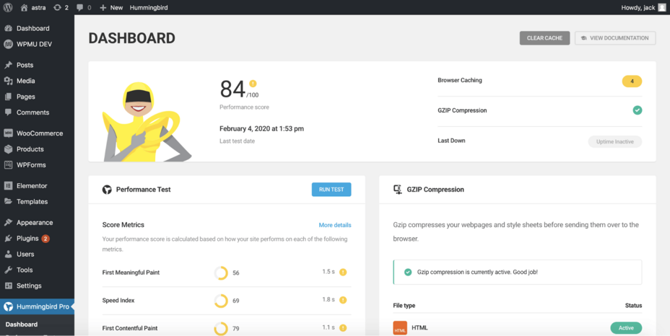

Without a doubt, our favorite feature of Hummingbird is the detailed performance report it’ll create of your website.

In this report, you’ll find suggestions, improvements, and detailed information about the [performance of your website](https://wpastra.com/guides-and-tutorials/speed-up-wordpress/) and what can be improved.

**Asset Optimization**

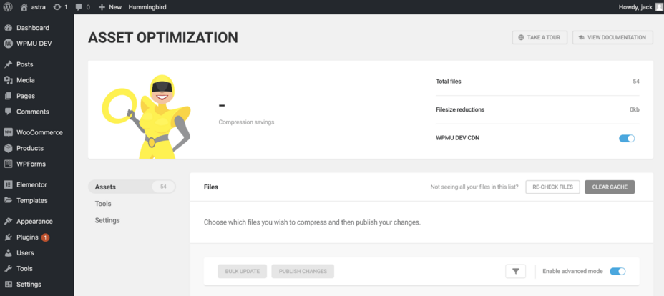

Simple, quick, and easy to use is the Asset Optimization functionality to minify and combine your files.

With a straightforward interface, Hummingbird is, without a doubt, the easiest to use the plugin to exclude files from being minified or combined, making it simple to resolve conflicts.

And of course, let’s not forget the WPMU DEV CDN, which allows you to offload all your website files to speed up your website. If you want to learn more about CDNs, [take a look at our article here.](https://wpastra.com/resources/top-cdn-providers/)

**Scheduled Database Optimization**

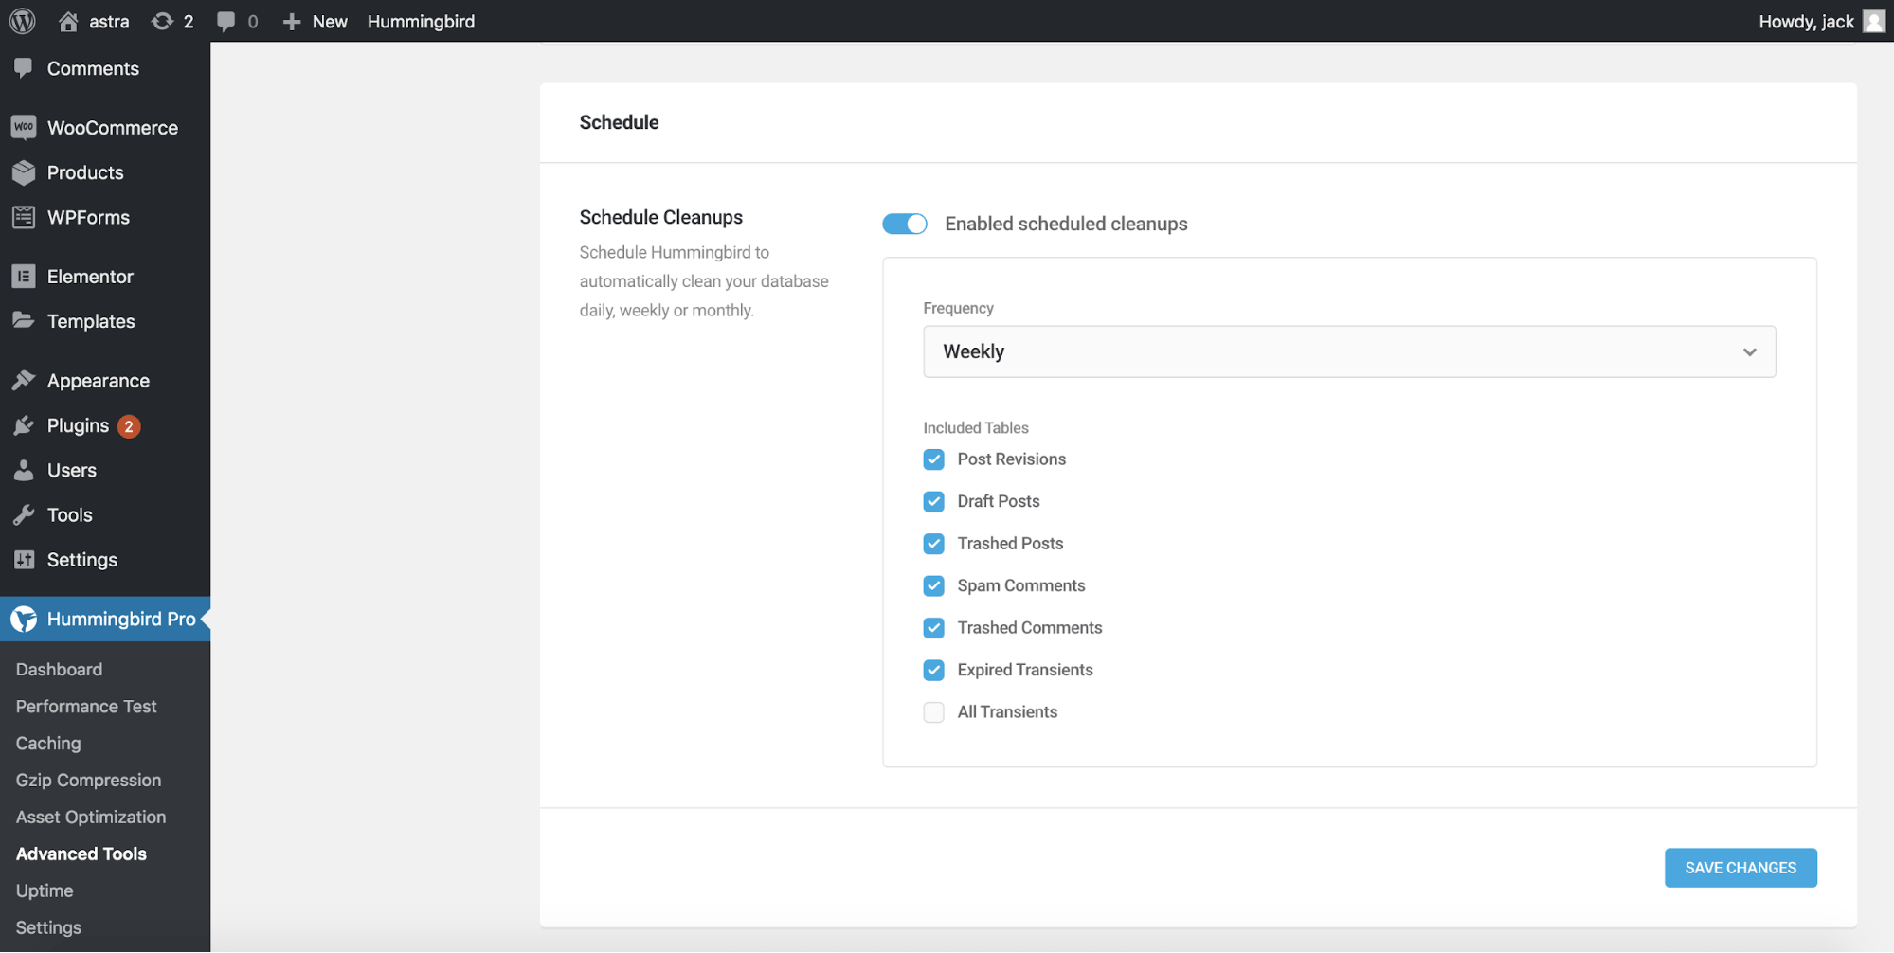

Out of the box, Hummingbird comes with database optimization, which is useful, but what’s even better is the automatic cleanup option.

The scheduled cleanup option allows you to set an interval for the database to be automatically optimized, such as removing drafts, post revisions, spam comments, expired transients, etc. Saving you the time and hassle of doing it yourself.

**What Are the Advantages of Hummingbird?**

User experience — Incredibly straightforward to use and with a lot of in-app help such as tooltips and wizards to help you get to grips with using the plugin.

Uptime Monitoring — Something that we’ve never seen in a caching plugin before, although it works perfectly in our testing and is definitely a useful feature to have.

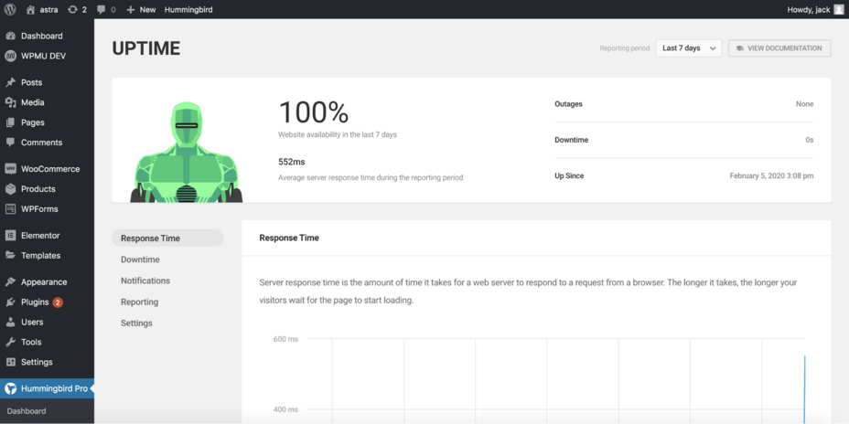

Caching — Naturally it comes without saying that the highlight of any caching plugin is well… caching. But Hummingbird offers more advanced caching than most plugins including:

* Page caching.
* Browser caching.
* Gravatar caching.
* RSS caching.
* Set cache expiry dates.
* Preload cache.

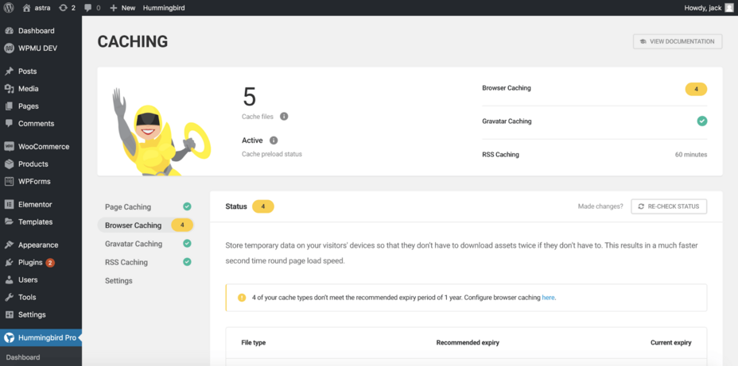

There are a whole bunch of caching options within Hummingbird, and no matter what type of website you have, you can be sure there’ll be a setup suitable for your website.

**Any Disadvantages of Hummingbird?**

The pricing is both an advantage and a disadvantage. If you can make use of WPMU DEV’s whole suite of tools and manage quite a few sites, the pricing is a bargain.

However, if you run just one site and don’t need all the other tools, then the pricing is very expensive. And you’d be better off using either a free alternative or something like WP Rocket.

Apart from this, there were some bugs in earlier versions that caused issues for both other users and ourselves. Although these have been ironed out, and no software is bug-free.

Overall there are no significant detractors to Hummingbird.

**Hummingbird Rating**

Feature set: 5/5

User interface: 4 / 5

Ease of use: 4/ 5

Support: 4.2 / 5

Pricing 2 /5 (based on if you only need one site).

Overall: 4 / 5

**Wrapping Up**

Hummingbird for WordPress is a tremendous all-around caching plugin with a robust feature set and a variety of positives, including Uptime monitoring.

While the pricing lets it down slightly, we’d still recommend [Hummingbird](https://wpastra.com/go/hummingbird/)for your [WordPress caching](https://wpastra.com/guides-and-tutorials/amp-for-wordpress/) needs.

Have you used Hummingbird before? Or perhaps you have a preferred caching plugin? Let us know in the comments below.

**Article by**



**Sujay Pawar**

Sujay Pawar is the co-founder and CEO of Brainstorm Force. He brings a one-of-a-kind fusion of tech brilliance, business savvy and marketing mojo to the table. Sujay has consistently spearheaded the development of innovative products like Astra, CartFlows, ZipWP and many others that have become market leaders in their respective niches.

**Disclosure:** This blog may contain affiliate links. If you make a purchase through one of these links, we may receive a small commission. [Read disclosure](https://wpastra.com/affiliate-disclosure/). Rest assured that we only recommend products that we have personally used and believe will add value to our readers. Thanks for your support!

**Join 1,587,020 Subscribers**

Get exclusive access to new tips, articles, guides, updates, and more.

Top of Form

Bottom of Form

**5 comments**

1. 

**Randall Whitted**

[May 12, 2020 at 4:38 AM](https://wpastra.com/review/hummingbird-caching-review/#comment-44474)

Nice – an actual speed test review. Thanks for the info! Would love to see a side-by-side comparison with WP Rocket.

[Reply](https://wpastra.com/review/hummingbird-caching-review/#comment-44474)

* 1. Team Astra Profile Pic 

**Team Astra**

[May 13, 2020 at 12:49 PM](https://wpastra.com/review/hummingbird-caching-review/#comment-44716)

Sure!

We’ll make a note of it.

[Reply](https://wpastra.com/review/hummingbird-caching-review/#comment-44716)

1. 

**Kristin**

[September 3, 2020 at 5:17 PM](https://wpastra.com/review/hummingbird-caching-review/#comment-65891)

I’m using the pro version — so far i’m loving it. I am still struggling with asset optimization as I have wordfence installed and have found that wordfence does not like when you try to minify/compress or do anything and blocks this. So i’m going to try and install hummingbirds defender and then try again. I haven’t gone super deep into this portion of the asset optimization yet as I’m still trying to understand how to undo it if I “break” a site — I am a bit of a noob when it comes to this part — but i am finding that the prompts just in the last week of using it has been so educational for this self taught web gal. 100% loving it so far.

[Reply](https://wpastra.com/review/hummingbird-caching-review/#comment-65891)

* 1. Dinnae Profile Pic 

**Dinnae**

[October 10, 2020 at 8:53 AM](https://wpastra.com/review/hummingbird-caching-review/#comment-69867)

If you use all their plugins together – they play SO nice. I’m rebuilding 3 brand sites this year, and the foundation of the sites will be astra and wpmu dev (including the hosting), with a couple others added in.

[Reply](https://wpastra.com/review/hummingbird-caching-review/#comment-69867)

1. Dinnae Profile Pic 

**Dinnae**

[October 10, 2020 at 8:55 AM](https://wpastra.com/review/hummingbird-caching-review/#comment-69868)

Thank you so much for this review. I’m a big fan of WPMU DEV stuff, and just recently found Astra, so I’m stoked that they work well together.

[Reply](https://wpastra.com/review/hummingbird-caching-review/#comment-69868)

2. Reddit

[](https://www.reddit.com/r/Wordpress/)

[Go to Wordpress](https://www.reddit.com/r/Wordpress/)

[**r/Wordpress**](https://www.reddit.com/r/Wordpress/)•1 yr. ago

[Superb-Ad-885](https://www.reddit.com/user/Superb-Ad-885/)

**Hummingbird or Better?**

Anyone have advise on how to optimize my site.? I need it to run faster. Thoughts on the Hummingbird plugin? Any help would be very much appreciated.

Upvote1Downvote10Go to commentsShare

Sort by:Best

Search CommentsExpand comment search

**Comments Section**

**New to Reddit?**

Create your account and connect with a world of communities.

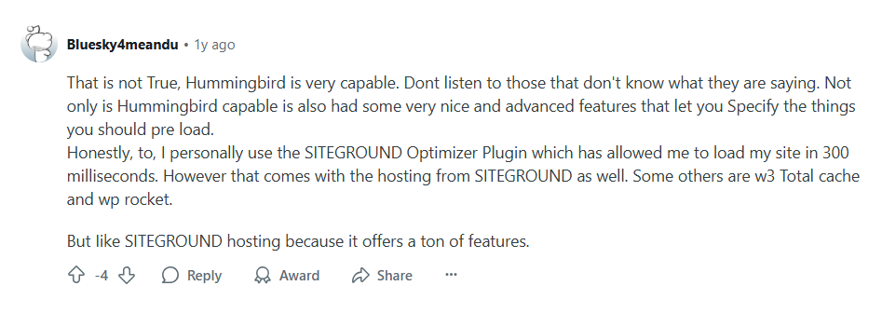

1. Slashdot

* [Software](https://slashdot.org/software/)
* [Web Accelerator Software](https://slashdot.org/software/web-accelerator)
* Hummingbird



**Hummingbird Reviews**

**WPMU DEV**

[Write a Review](https://slashdot.org/software/p/Hummingbird-Pro/reviews/new)

[**Alternatives**](https://slashdot.org/software/p/Hummingbird-Pro/alternatives)

**Claim this page**

**Hummingbird Description**

Easily pinpoint HTML, JavaScript, and CSS files that are suitable for compression, consolidation, or relocation to enhance overall performance. Utilize the integrated Safe Mode to test any adjustments before they go live. Hummingbird Pro serves as the perfect performance optimization tool for everyone—whether you seek straightforward, one-click fixes or wish to meticulously adjust your site's performance to the finest detail of your CSS files. Additionally, each individual plugin grants you comprehensive access to our Pro Plugins, Full Hub features, and all associated services at no added expense. Manage Automated Updates, configurations, performance metrics, uptime monitoring, analytics, reporting, support, client billing, and white labeling from a centralized command center. Furthermore, Hummingbird is designed to fully leverage the capabilities of Cloudflare; simply enter your API key to get started and manage your Cloudflare settings conveniently through Hummingbird. This seamless integration allows for a more streamlined experience, ensuring that your site performs at its best while saving you time and effort.

**Hummingbird Alternatives**



**Imagify**

(91 Ratings)

Imagify is a user-friendly WordPress plugin that simplifies image optimization for faster websites. It compresses and resizes images while converting them to next-gen formats like WebP and Avif, all with a single click. Developed by the creators of WP Rocket, Imagify balances image quality with performance to speed up page load times and boost your PageSpeed Insights and Core Web Vitals scores. Even if you have many large images slowing down your site, Imagify handles bulk compression quickly and efficiently, without needing any technical expertise. The plugin’s smart compression technology ensures images stay visually excellent while significantly reducing file size. By improving loading speed, it enhances SEO rankings and encourages visitors to stay longer on your site, increasing the chance of conversions. Users can monitor performance improvements through an intuitive dashboard that shows before-and-after compression statistics. With strong community endorsements, Imagify is trusted by professionals who want a hassle-free solution to image optimization.

[**Learn more**](https://slashdot.org/software/link?oaparams=2__bannerid=87530__zoneid=84929__cb=b9b53d1ef730f9aadbfd__oadest=https%3A%2F%2Fimagify.io%2F)



**Fastly**

(822 Ratings)

Today's top edge cloud platform empowers developers, connects with customers, and grows your business. Our edge cloud platform is designed to enhance your existing technology and teams. Our edge cloud platform moves data and applications closer towards your users -- at a network's edge -- to improve the performance of your websites and apps. Fastly's highly-programmable CDN allows you to personalize delivery right at the edge. Your users will be delighted to have the content they need at their fingertips. Our powerful POPs are powered by solid-state drives (SSDs), and are located in well-connected locations around world. They allow us to keep more content in cache for longer periods of time, resulting in fewer trips back to the source. Instant Purge and batch purging using surrogate keys allow you to cache and invalidate dynamic content in a matter of minutes. You can always serve up current headlines, inventory, and weather forecasts.

[**Learn more**](https://slashdot.org/software/link?oaparams=2__bannerid=77399__zoneid=74795__cb=a37e5f9b86e64ef8a41e__oadest=https%3A%2F%2Fwww.fastly.com%2Fproducts%3Futm_source%3Dsourceforge%26utm_medium%3Dreferral%26utm_campaign%3Dsourceforgelisting)



**W3 Total Cache**

Recent studies indicate that even a minor improvement in page load speed compared to competitors can trigger physiological responses, including elevated blood pressure and increased stress hormones. Google actively penalizes websites that load slowly while favoring those that enhance user experience, making it crucial to optimize your site. One effective tool for achieving this optimization is W3 Total Cache. It is typically compatible with a wide range of hosting options, including shared, VPS, and dedicated server plans. The installation and setup process is straightforward, allowing for quick implementation. W3 Total Cache significantly enhances the speed of your WordPress site, ensuring that both mobile and desktop users experience rapid loading times. By upgrading to W3 Total Cache Pro, you can further boost your website's performance with access to premium features like advanced analytics, fragment caching, full site delivery, extension support, and a variety of other tools designed to refine your site’s efficiency. This comprehensive approach to performance optimization can lead to improved user satisfaction and retention as well.

[**Learn more**](https://slashdot.org/software/p/W3-Total-Cache/)



**Edgemesh**

Step into a realm where page loads occur in mere moments, significantly boosting your conversion rates, suitable for any e-commerce system. Experience a seamless headless solution that avoids the need for expensive or disruptive website overhauls. Get started in just minutes without the burden of additional infrastructure or the complexity of new frontend processes. Maintain your current backend and developer workflow while incorporating top-tier edge performance. With Edgemesh Server, every page load is remarkably swift. Indeed, even on heavily utilized and cluttered e-commerce systems, astonishingly rapid performance is within your reach. On our ultra-fast edge network, you’ll notice your connection speeds are measured in milliseconds rather than seconds. If you appreciate your current website, Edgemesh Server allows you to adopt a headless architecture while preserving its existing look and feel, as it supports a wide array of eCommerce applications and plugins right out of the box. This means you can enhance your site's speed and efficiency without sacrificing the user experience your customers love.

[**Learn more**](https://slashdot.org/software/p/Edgemesh/)

**Pricing**

**Pricing Starts At:**

$7.50 per month

**Free Trial:**

Yes

**Integrations**

**API:**

Yes, Hummingbird has an API

[**View Integrations**](https://slashdot.org/software/p/Hummingbird-Pro/integrations/)

**Reviews**

**Total**

**ease**

**features**

**design**

**support**

**No User Reviews. Be the first to provide a review:**

[**Write a Review**](https://slashdot.org/software/p/Hummingbird-Pro/reviews/new)

**Company Details**

**Company:**

**WPMU DEV**

**Year Founded:**

2007

**Headquarters:**

United States

**Website:**

wpmudev.com/project/wp-hummingbird/

**Media**

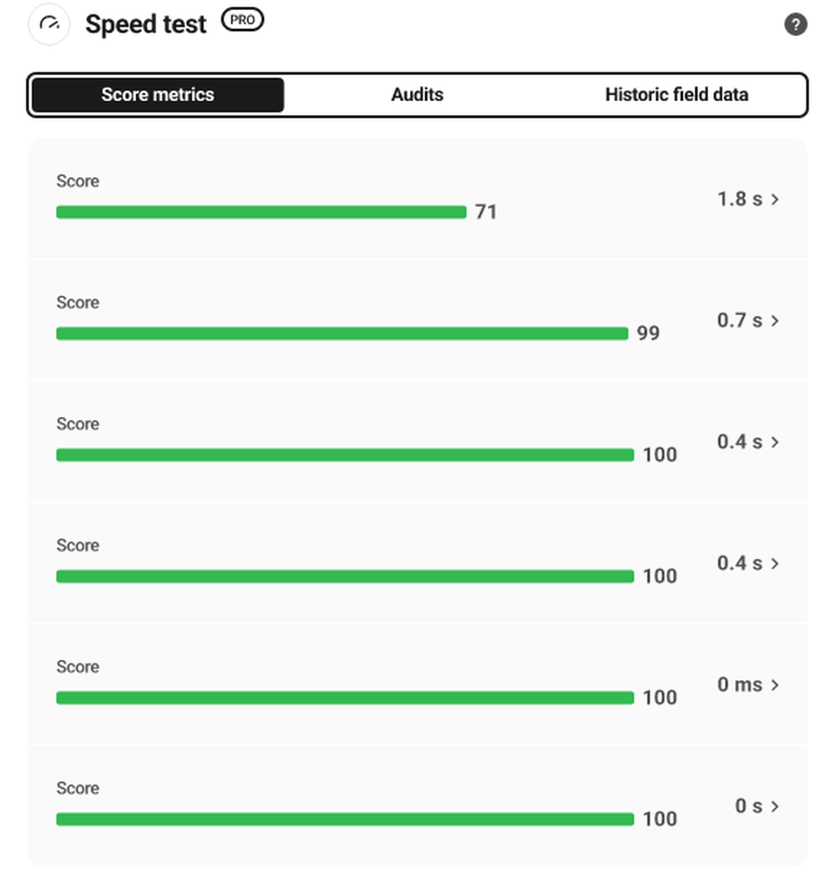

**Recommended Products**



**Get your free 3CX license delivered to your inbox. Easy deployment and management; on premise or in the cloud, 3CX includes features such as: mobile apps, web conferencing, live chat, click2call and more, for UNLIMITED users.**

**Business as Usual During Covid-19**

3CX is a software-based, open standards IP PBX that offers complete Unified Communications, out of the box. Suitable for any business size or industry 3CX can accommodate your every need; from mobility and status to advanced contact center features and more, at a fraction of the cost. 3CX makes installation, management and maintenance of your PBX so easy that you can effortlessly manage it yourself, whether on an appliance or server at your premise on Windows, Linux or in the cloud.

**DOWNLOAD**

**Platforms**

 Web-Based

**Types of Training**

 Training Docs

**Customer Support**

 Online Support

**Hummingbird Features and Options**

[**Web Accelerator Software**](https://slashdot.org/software/web-accelerator/)

**Hummingbird User Reviews**

[Write a Review](https://slashdot.org/software/p/Hummingbird-Pro/reviews/new)

* Previous

* Next

**Compare Hummingbird Against Alternatives**

[[Hummingbird Reviews](https://slashdot.org/software/comparison/Hummingbird-Pro-vs-W3-Total-Cache/)](https://slashdot.org/software/comparison/Hummingbird-Pro-vs-W3-Total-Cache/" \o "Compare Against Hummingbird)

[vs.](https://slashdot.org/software/comparison/Hummingbird-Pro-vs-W3-Total-Cache/" \o "Compare Against Hummingbird)

[[W3 Total Cache Reviews](https://slashdot.org/software/comparison/Hummingbird-Pro-vs-W3-Total-Cache/)](https://slashdot.org/software/comparison/Hummingbird-Pro-vs-W3-Total-Cache/" \o "Compare Against Hummingbird)

[**W3 Total Cache**](https://slashdot.org/software/comparison/Hummingbird-Pro-vs-W3-Total-Cache/)

Recent studies indicate that even a minor improvement in page load speed compared to competitors can trigger physiological responses, including elevated blood pressure and increased stress hormones. Google actively penalizes websites that load slowly while favoring those that enhance user...

[**Compare**](https://slashdot.org/software/comparison/Hummingbird-Pro-vs-W3-Total-Cache/)

[[Hummingbird Reviews](https://slashdot.org/software/comparison/Edgemesh-vs-Hummingbird-Pro/)](https://slashdot.org/software/comparison/Edgemesh-vs-Hummingbird-Pro/" \o "Compare Against Hummingbird)

[vs.](https://slashdot.org/software/comparison/Edgemesh-vs-Hummingbird-Pro/" \o "Compare Against Hummingbird)

[[Edgemesh Reviews](https://slashdot.org/software/comparison/Edgemesh-vs-Hummingbird-Pro/)](https://slashdot.org/software/comparison/Edgemesh-vs-Hummingbird-Pro/" \o "Compare Against Hummingbird)

[**Edgemesh**](https://slashdot.org/software/comparison/Edgemesh-vs-Hummingbird-Pro/)

Step into a realm where page loads occur in mere moments, significantly boosting your conversion rates, suitable for any e-commerce system. Experience a seamless headless solution that avoids the need for expensive or disruptive website overhauls. Get started in just minutes without the burden...

[**Compare**](https://slashdot.org/software/comparison/Edgemesh-vs-Hummingbird-Pro/)

[[Hummingbird Reviews](https://slashdot.org/software/comparison/Hummingbird-Pro-vs-SiteGround/)](https://slashdot.org/software/comparison/Hummingbird-Pro-vs-SiteGround/" \o "Compare Against Hummingbird)

[vs.](https://slashdot.org/software/comparison/Hummingbird-Pro-vs-SiteGround/" \o "Compare Against Hummingbird)

[[SiteGround Reviews](https://slashdot.org/software/comparison/Hummingbird-Pro-vs-SiteGround/)](https://slashdot.org/software/comparison/Hummingbird-Pro-vs-SiteGround/" \o "Compare Against Hummingbird)

[**SiteGround**](https://slashdot.org/software/comparison/Hummingbird-Pro-vs-SiteGround/)

Experience rapid and reliable web hosting tailored for both personal and business websites. What sets SiteGround apart is our incredible team, who have been committed to providing outstanding service since 2004. Each day, we channel our enthusiasm, dedication, and expertise into ensuring the...

[**Compare**](https://slashdot.org/software/comparison/Hummingbird-Pro-vs-SiteGround/)

[[Hummingbird Reviews](https://slashdot.org/software/comparison/Hummingbird-Pro-vs-WP-Rocket/)](https://slashdot.org/software/comparison/Hummingbird-Pro-vs-WP-Rocket/" \o "Compare Against Hummingbird)

[vs.](https://slashdot.org/software/comparison/Hummingbird-Pro-vs-WP-Rocket/" \o "Compare Against Hummingbird)

[[WP Rocket Reviews](https://slashdot.org/software/comparison/Hummingbird-Pro-vs-WP-Rocket/)](https://slashdot.org/software/comparison/Hummingbird-Pro-vs-WP-Rocket/" \o "Compare Against Hummingbird)

[**WP Rocket**](https://slashdot.org/software/comparison/Hummingbird-Pro-vs-WP-Rocket/)

WP Rocket transcends the typical role of a WordPress caching plugin, serving as a formidable tool to enhance loading speeds, elevate your PageSpeed scores, and fine-tune your Core Web Vitals. Recommended by WordPress professionals, WP Rocket stands out as the premier caching solution, delivering...

[**Compare**](https://slashdot.org/software/comparison/Hummingbird-Pro-vs-WP-Rocket/)

[[Hummingbird Reviews](https://slashdot.org/software/comparison/Cachify-vs-Hummingbird-Pro/)](https://slashdot.org/software/comparison/Cachify-vs-Hummingbird-Pro/" \o "Compare Against Hummingbird)

[vs.](https://slashdot.org/software/comparison/Cachify-vs-Hummingbird-Pro/" \o "Compare Against Hummingbird)

[[Cachify Reviews](https://slashdot.org/software/comparison/Cachify-vs-Hummingbird-Pro/)](https://slashdot.org/software/comparison/Cachify-vs-Hummingbird-Pro/" \o "Compare Against Hummingbird)

[**Cachify**](https://slashdot.org/software/comparison/Cachify-vs-Hummingbird-Pro/)

Cachify enhances the speed of your page loads by transforming posts, pages, and custom post types into static content that can be cached. Users have the option to cache data through the database, the hard drive of the web server (HDD), or directly within the server's system cache utilizing APC...

[**Compare**](https://slashdot.org/software/comparison/Cachify-vs-Hummingbird-Pro/)

**Similar Software**

* WP-Optimize Reviews

[**WP-Optimize**](https://slashdot.org/software/p/WP-Optimize/)

The database of your WordPress site is essential for storing all necessary information, along with a lot of extraneous data. Utilizing the WP-Optimize feature, you can effectively eliminate this superfluous information, tidy up your tables, and recover space that may have been lost due to data...

[**View Software**](https://slashdot.org/software/p/WP-Optimize/)

* HTMeLd Reviews

[**HTMeLd**](https://slashdot.org/software/p/HTMeLd/)

The speed of your website directly affects your Google Page Experience score, and therefore your Google rank. HTMeLd improves upon this by scanning each page for external resources like images, style sheets, and scripts. Then it embeds these files directly in the HTML. This eliminates the...

[**View Software**](https://slashdot.org/software/p/HTMeLd/)

* Edgemesh Reviews

[**Edgemesh**](https://slashdot.org/software/p/Edgemesh/)

Step into a realm where page loads occur in mere moments, significantly boosting your conversion rates, suitable for any e-commerce system. Experience a seamless headless solution that avoids the need for expensive or disruptive website overhauls. Get started in just minutes without the burden...

[**View Software**](https://slashdot.org/software/p/Edgemesh/)

* W3 Total Cache Reviews

[**W3 Total Cache**](https://slashdot.org/software/p/W3-Total-Cache/)

Recent studies indicate that even a minor improvement in page load speed compared to competitors can trigger physiological responses, including elevated blood pressure and increased stress hormones. Google actively penalizes websites that load slowly while favoring those that enhance user...

[**View Software**](https://slashdot.org/software/p/W3-Total-Cache/)

* WP Rocket Reviews

[**WP Rocket**](https://slashdot.org/software/p/WP-Rocket/)

WP Rocket transcends the typical role of a WordPress caching plugin, serving as a formidable tool to enhance loading speeds, elevate your PageSpeed scores, and fine-tune your Core Web Vitals. Recommended by WordPress professionals, WP Rocket stands out as the premier caching solution, delivering...

[**View Software**](https://slashdot.org/software/p/WP-Rocket/)

1. SourceForge
2. [Home](https://sourceforge.net/)
3. [Compare Business Software](https://sourceforge.net/software/)
4. [Web Accelerator Software](https://sourceforge.net/software/web-accelerator)
5. Hummingbird



**Hummingbird**

**WPMU DEV**

[Write a Review](https://sourceforge.net/software/product/Hummingbird-Pro/reviews/new)

[**Alternatives to Hummingbird**](https://sourceforge.net/software/product/Hummingbird-Pro/alternatives)

**Claim this page**

**Popular Alternatives & Related Software**



**Fastly**

(822 Ratings)

Empower your developers, connect with your customers, and grow your business with today’s leading edge cloud platform. Deliver the best online experiences possible with our edge cloud platform, built to strengthen your current teams and technology. We move data and applications closer to your users — at the edge of the network — to help your websites and apps perform faster, safer, and at global scale. Fastly's highly programmable CDN gives you the freedom to customize delivery right at the edge. Delight your users with the content they want at their fingertips. Our powerful POPs, driven by solid-state drives (SSDs) and hosted in well-connected locations around the world, help us keep more content in cache longer for fewer trips to the origin. Instant Purge and batch purging with surrogate keys let you cache and invalidate highly dynamic content with a mean purge time of 150 milliseconds*. Serve headlines, inventory, or weather forecasts that are always up to date.

[**Learn more**](https://sourceforge.net/software/link?oaparams=2__bannerid=77393__zoneid=74789__cb=9d0ced055195b543a487__oadest=https%3A%2F%2Fwww.fastly.com%2Fproducts%3Futm_source%3Dsourceforge%26utm_medium%3Dreferral%26utm_campaign%3Dsourceforgelisting)



**Imagify**

(91 Ratings)

Imagify is a powerful and easy-to-use WordPress plugin designed to optimize images and speed up your website. It automatically compresses, resizes, and converts images to modern formats like WebP and Avif with just one click. Created by the team behind WP Rocket, Imagify guarantees improved website loading times without sacrificing image quality. It enhances key performance metrics such as Google PageSpeed scores and Core Web Vitals. Imagify is ideal for users who want a quick and efficient way to compress large image files in bulk without any technical knowledge. Overall, it helps businesses improve SEO, user experience, and conversions by making images lighter and faster to load.

[**Learn more**](https://sourceforge.net/software/link?oaparams=2__bannerid=87527__zoneid=84926__cb=b887985e2decd073e1c5__oadest=https%3A%2F%2Fimagify.io%2F)



**Edgemesh**

Welcome to a world of sub-second page loads, and increased conversion rates, available for any e-commerce platform. A pain-free headless experience, without costly or painful website redesigns. Be up and running in minutes, without adding extra infrastructural overhead or introducing complicated new frontend workflows. Keep your existing backend and developer experience and add industry-leading edge performance. With Edgemesh Server, every single page load is fast. Yes, even on over-taxed and bloated e-commerce platforms, you can achieve insanely fast performance speeds. On our lightning-fast edge network, you can measure your connection speeds in milliseconds, not seconds. Do you like your website? Edgemesh Server will enable you to go headless, and still keep your website almost exactly as it is today, with most eCommerce applications and plugins supported out of the box.

[**Learn more**](https://sourceforge.net/software/product/Edgemesh/)

**Audience**

Anyone searching for a powerful Web Accelerator solution

**About Hummingbird**

Easily identify HTML, Javascript, and CSS files that can be compressed, combined, or moved to maximize performance. Test changes before pushing live with built-in Safe Mode. Hummingbird Pro is the ideal performance plugin for all users - whether you’re looking for simple, one-click solutions, or to fine-tune your site performance down to the last CSS file. All single plugins come with complete access to our Pro Plugins, Full Hub access and all of our services at no extra cost. Run Automated Updates, configs, performance, uptime, analytics, reports, support, client billing and white labeling management from one command center. Hummingbird is built to take full advantage of Cloudflare features. Just plug in your API key to get started and control your Cloudflare settings via Hummingbird.

6. Wordpress.org

**[Hummingbird Performance - Cache & Page Speed Optimization for Core Web Vitals | Critical CSS | Minify CSS | Defer CSS Javascript | CDN] Reviews**

1. Slowed my site down

* [WingRider](https://wordpress.org/support/users/wingrider/)

(@wingrider)

[9 months ago](https://wordpress.org/support/topic/slowed-my-site-down-2/)

Well done for creating an optimisation plugin which materially slowed my site down. Tested on pingdom before and after multiple times and with every optimisation switched on my site was significantly slower with Hummingbird.

* + This topic was modified 9 months ago by [WingRider](https://wordpress.org/support/users/wingrider/" \o "View WingRider's profile).

Viewing 1 replies (of 1 total)

* Plugin Support[Kris – WPMU DEV Support](https://wordpress.org/support/users/wpmudevsupport13/)

(@wpmudevsupport13)

[9 months ago](https://wordpress.org/support/topic/slowed-my-site-down-2/#post-18115193)

Hi [**@wingrider**](https://wordpress.org/support/users/wingrider/)

I hope you are doing well today.

In the first place, we recommend our full docs for Hummingbird, which can help with tips on how to use the full potential of Hummingbird:  
<https://wpmudev.com/docs/wpmu-dev-plugins/hummingbird/>

We also encourage you to make a fresh topic with us here: <https://wordpress.org/support/plugin/hummingbird-performance/#new-topic-0> so we can ask for more details about your current setup and also check your site name to test that not only on Pingdom but also on PageSpeed Insights to suggest you steps to get a better score, so in the end, you will be satisfactory with our product.

Kind Regards,  
Kris

1. I can say that it really had no effect

* [Amirhossein Shiasi](https://wordpress.org/support/users/amirygnv/)

(@amirygnv)

[10 months ago](https://wordpress.org/support/topic/i-can-say-that-it-really-had-no-effect/)

Not being was better than being

Viewing 1 replies (of 1 total)

* Plugin Support[Patrick – WPMU DEV Support](https://wordpress.org/support/users/wpmudevsupport12/)

(@wpmudevsupport12)

[9 months, 4 weeks ago](https://wordpress.org/support/topic/i-can-say-that-it-really-had-no-effect/#post-18069512)

Hi [**@amirygnv**](https://wordpress.org/support/users/amirygnv/)

I hope you are doing well and sorry to hear you feel the plugin wasn’t helpful.

We would like to understand more why the plugin didn’t perform well on your website.

Did it cause any issues or hasn’t the score improved as you would like?

Since we couldn’t see any support thread under your profile, [wouldn’t you mind opening a new thread by clicking here](https://wordpress.org/support/plugin/hummingbird-performance/#new-topic-0) and I hope we can convert it into a 5-stars experience.

Best Regards  
Patrick Freitas

1. No and NO – Good bye Humming Bird

* [Davinciii](https://wordpress.org/support/users/earthdye/)

(@earthdye)

[1 year ago](https://wordpress.org/support/topic/no-and-no-good-bye-humming-bird/)

Let me start by saying, I love WPMUDEV, I have loved them and been with them a very long time now. The tech support is second to none and 24/7. With out them I’d be toast. I went with them because of that and the fact they have very alluring plug ins and hummingbird is one of them. I have dealt with humming bird and Smush off and on well over 5 years now. It has been an absolute hell. Humming bird will crash your site and has hundreds of on off features. The “only” way to know which one will affect you is to turn it on, wait for it to propagate and check it and then on to the next. This can take weeks. Then you have a plugin update and the hunt to find what is causing the site to crash is on. 9/10 you can just turn off hummingbird and it goes away. THEN you have to do the same crap all over again. turn one feature off, wait, propagate, check and onto the next one. This is like pulling your own toe nails out and at a snails pace. Another problem is hummingbird causes the entire back end to load SUPER SLOW! Talk about anxiety!! I have a few sites with Woocommerce and similar templates, so now you have your work cut out for you. So then you get on tech support. They tell you what I just told you, and they will take a look at it and if you get a great tech they can even fix a few things. However with extreme limitations.

So now they introduce a new feature. For 400 bucks you can hire there certified humming bird specialist. WOW, so yes the plugin is free, but I also pay over 75.00 per site per month and have done so for years.

I had to upgrade my plan to make the back end faster loading for my main site, which did absolutely nothing. Meanwhile I do have several paid cloudflare accounts and it hit me today. Isnt that enough? So I turned humming bird off and guess what? Just using cloudlfare my site loads like a wild banji with its ass on fire. WHAT A TRIP!!!! and My back end now loads super fast. It was hummingbird the entire time!!

Counteless broken pages, countless security issues, countless cart issues and countless other problems. My file for support is ginormas and it all came down to one plugin. Humming bird.

How did I learn all of this finally? I got a Semrush account and scanned my site. Hummingbird CSS and java scripts errors all over the place. It was clashing with Woo and everything else and they had told me I need a new theme and was literally in the middle of painstakingly moving the website. Countless hours and thousands of dollars out the window and they want 400 to have there team set it up, but what happens when it updates or another plugin updates? Anotehr problem is HB and CF both have many of the same features. and it is up to you to determine which is on with one and the other. To many caches. You have them on the server side and on the website and on CF. TO MANY CACHE! Then if you have already compressed your photos and turn it on, guess what, they are super blurred and double compressed. Also if you ever delete it or move later, now you have to go back and compress them all. Dont be lazy and just compress them before you ad them.

Conclusion:

If you are using a blog, or a simple site, sure, use the freebies/paid. If you are like me and take it serious/ecommerce stay far far away. The majority sites out there are not e-commerce, I assume that is why it has such great reviews. After years and years of wasted time it works better off. This is also what caused the site to take hours to propagate, even after purging CF cache (This was there techs favorite solution, Did you clear the cache?). Im not 100% but I am pretty sure every time you add a page you should not have to clear the main cloudflare cache. The worst part is all these years and time and not one of the techs figured it out. But the reasoning behind it was because it took so long to propagate; even with a cleared cache, it was consistently overlooked.

And yes I will continue to use WPMUDEV, just not smush or HB.

Viewing 4 replies - 1 through 4 (of 4 total)

* Plugin Support[Kris – WPMU DEV Support](https://wordpress.org/support/users/wpmudevsupport13/)

(@wpmudevsupport13)

[1 year ago](https://wordpress.org/support/topic/no-and-no-good-bye-humming-bird/#post-17910708)

Hi [**@earthdye**](https://wordpress.org/support/users/earthdye/)

I hope you are doing well today.

Thank you for the good and bad parts pointed out by you in this review. Allow me to refer to some of them, especially the bad ones in your opinion.

When it comes to your issues with Hummingbird, please note we improved and still improve things when it comes to this tool. It seems you mainly refer to Assets Optimization which can break the design site if that tool is not used correctly.  
Each of our tools or features is covered in our docs (<https://wpmudev.com/docs/wpmu-dev-plugins/hummingbird/#asset-optimization>) and our support is always ready to help to narrow down the main issue our members or users on this forum reports.

As a side note Assets Optimization now has an Automatic Mode option which is safer for less experienced users <https://wpmudev.com/docs/wpmu-dev-plugins/hummingbird/#assets-optimization>  
Manual Mode always required some knowledge about own site and used plugins.

With that Automated feature, which compresses and combines the assets, delay the JS and generates the Critical CSS, we have been also applying major compatibilities with the most popular plugins and themes, however, delaying a JS or using the manual mode can break the site in case it has a higher dependency on the JS files, example if we delay jQuery but another script depends on it, this isn’t a Hummingbird thing but happens with any delay JS method.

Please note there are over 60k plugins in the org repository and thousands of themes on the market. With that each of the sites which uses WP core is different. Following this we cannot know how theme and plugins authors design the core of JS and CSS files.

More experienced users will for sure know how things work and how to use our tool, but that does not mean we push less experienced on a side track and not help them. Like 60k plugins in the WP repository, there are thousands of examples of users who work in other industries (sellers, bloggers, writers) who still need WP core to handle their sites and plugins which can help to speed up them.

Another note is that the full assets optimization can take up to 40 minutes, however, in the latest update we split the Delay JS and Critical CSS queue from the Assets Optimization ( combine compress ) queue, in case any of them is breaking anything it would be visible faster than before.

Moving on with different plugin setups and themes, there is always the possibility that some sites will be faster or slower depending on how many of them you use on your site. If we mix that with another factor which is different hosting providers that offer different server resources things again can have a better or worse reflection on site speed (not only frontend but backend as well).

====

When it comes to the new feature we offer which is a paid service for site optimisation, there is nothing odd or bad in that. Let’s take another example which will be any other plugin in WP repositories, even the free ones, which do not offer Pro paid membership. As a free user in the WP repository, I install the plugin, check docs, and ask for help to solve issues if necessary. I do not ask to fully configure the plugin on my site, as this is my responsibility to get familiar with docs and configure plugin on my own. If I cannot handle that (let’s say I’m a blogger) I hire a developer to handle that. So why as a company we cannot offer such paid feature that is useful for such members? Also, having in mind that this service comes from the same people who make that plugin, why not hire them instead of 3rd party developers who use Hummingbird from time to time? I have to fully disagree with you in that matter and again there is nothing odd or bad in that offer.

Also, we have a lot of members, who run multiple websites and don’t have time to speed optimize new complex sites that’s why they hire us to do speed optimization. For the majority of sites enabling a few Automated Optimization options should be enough to get a high performance score. For more complex sites users may need to do extra configurations.

====

If you have any kind of issues with images, please note that Smush has 3 levels of compression in the paid version and it is recommended to test things on 1 image in the first place before BULK SMUSH thousands of images. As you possibly know Smush has also a feature to back up your images and any image that will be affected by compression can be reversed. In general, is it also a good practice to have any kind of backup plugin or backup service on your hosting.  
I need to again disagree here with you as this is the user’s responsibility to get familiar with the documentation and functionality of the plugin.

====

As for Cloudflare, unfortunately, without a deeper check, we can’t know what happened there, as previously explained it is not an expected behavior, please email us at [contact@wpmudev.com](mailto:contact@wpmudev.com) in case you have any open tickets on our pro forums and we can verify what happened.

As for Semrush, similar as explained it is not possible to say what happened without checking, but in general when the CSS and JS are combined and compressed under the Hummingbird Assets Optimization, those codes still being from the plugins and themes but just under different URL.

Kind Regards,  
Kris

Thread Starter[Davinciii](https://wordpress.org/support/users/earthdye/)

(@earthdye)

[1 year ago](https://wordpress.org/support/topic/no-and-no-good-bye-humming-bird/#post-17920469)

Thanks for the response. Just the fact that I learned that HB is responsible for my slow propagating and slow backend is good reason not to use it. My site propagates almost instantly now, this is how it should be. Doing an update and then having to wait 45 minutes or longer, even after your cloudflare is cleared is not acceptable, I just thought it was wordpress. For most of us working and updating sites all day every day, time is money, not to mention waiting 30 seconds for the backend to load from product to plugins is enough to send your anxiety into a full blown anxiety attack. I pay a lot of money for the service which is more than worth it, however the final straw was the “hire us for 400.00” to optimize your humming bird ( maybe this is for folks not being hosted with WPMUDEV? Over the years the techs are phenomenal, but one thing is most of them lack experience with humming bird. So lets say you pay the 400.00 and get it working properly, that is only as good as the next update on other plugins and they you have to become a sleuth once again to figure it out, like you said, with thousands of plugins …. I do try and keep mine to a minimum, the ones I have I have to have. I highly recommend WPMUDEV, just not humming bird. Another thing is I was told to upgrade my back end years ago as it was so slow and it never made a difference. With HB removed it is 10x faster in the backend now. This also brings me to, isn’t cloudflare supposed to take care of all the speed issues, which is another service I pay for. Or maybe HB would work better without Cloudflare, but then with out a CDN, it would not be good. These are things we should not be worrying about.

Plugin Support[Saurabh – WPMU DEV Support](https://wordpress.org/support/users/wpmudev-support7/)

(@wpmudev-support7)

[1 year ago](https://wordpress.org/support/topic/no-and-no-good-bye-humming-bird/#post-17922157)

Hello [**@earthdye**](https://wordpress.org/support/users/earthdye/)

Thank you for your response.

When it comes to CDN, Hummingbird comes with a built-in CDN which is a Pro module, nevertheless, it also does integrate with Cloudflare, so ideally can be used with Cloudflare too.  
Ref: <https://wpmudev.com/docs/wpmu-dev-plugins/hummingbird/#cloudflare-integration>

However, I understand your frustration but without a deeper investigation, we cannot really confirm why it happened. As mentioned previously, we would love to take a deeper look into the issue, if you can provide a staging site. Please get in touch with us at [contact@wpmudev.com](mailto:contact@wpmudev.com) so that we can take a closer look.

Kind Regards,  
Saurabh

Thread Starter[Davinciii](https://wordpress.org/support/users/earthdye/)

(@earthdye)

[1 year ago](https://wordpress.org/support/topic/no-and-no-good-bye-humming-bird/#post-17934947)

That does make sense if they do not have a hosting account they can pay to have it set up. I will check in again, at the moment I am setting up a new template, so my staging is occupied. However in the past using the staging site you cannot perform speed test, unless I was told the wrong information.

Once I am done with the new template I will be happy to let you guys give it a go again. I love you guys and I do know you have been working to make it better (among so many other things), I wont give up and hopefully can come back and update this review.

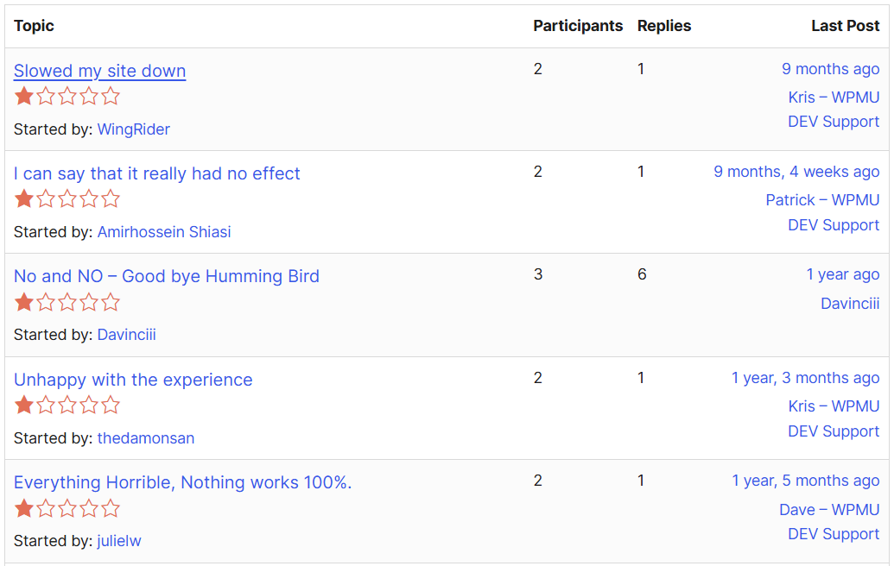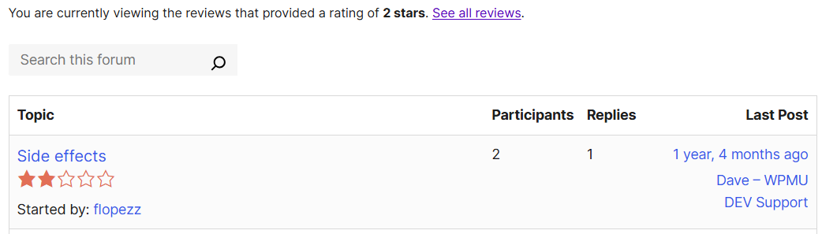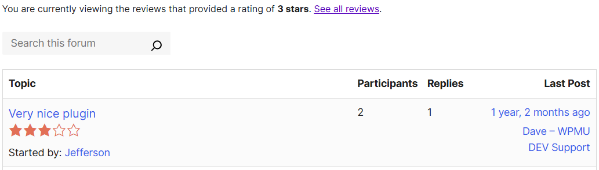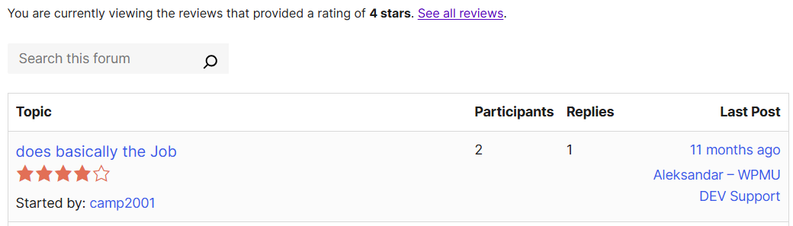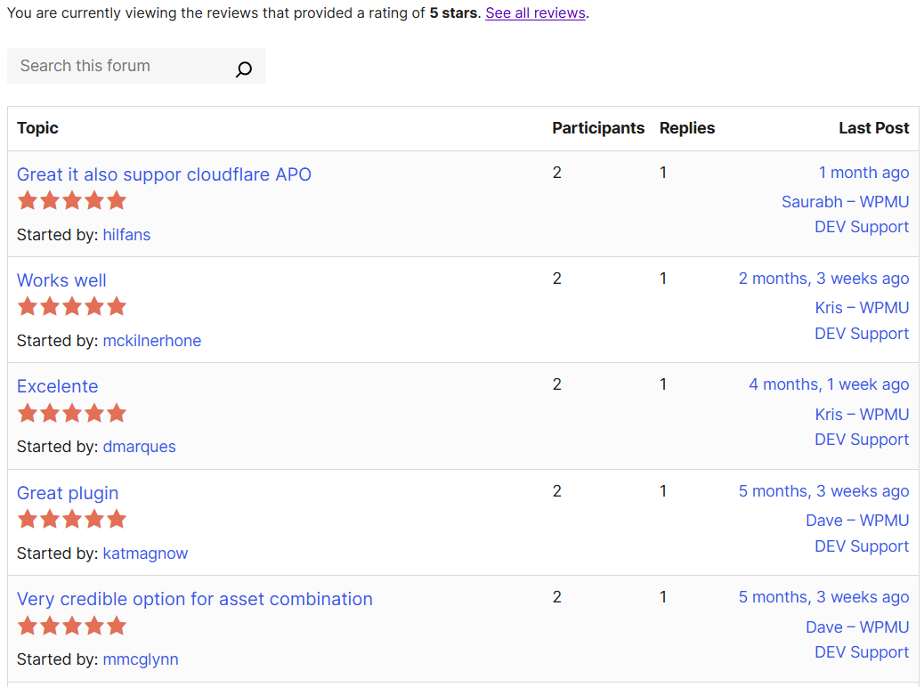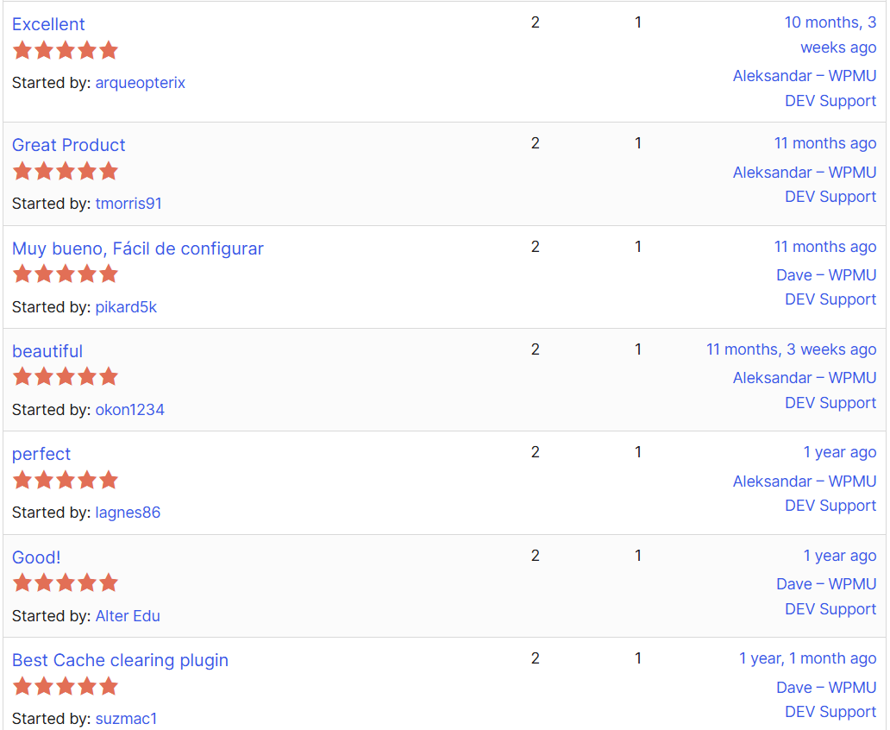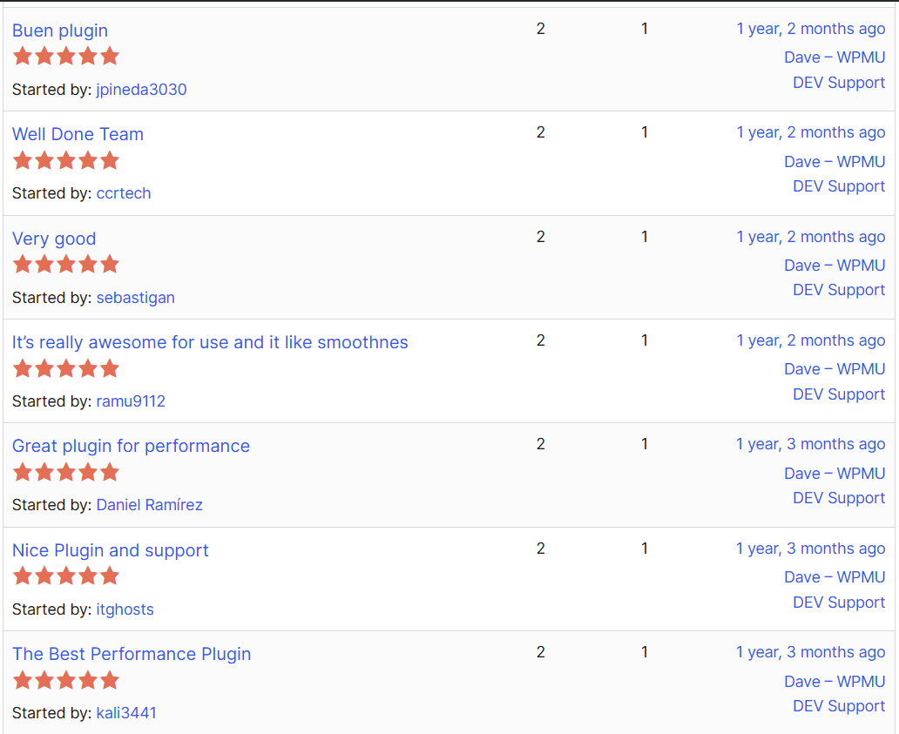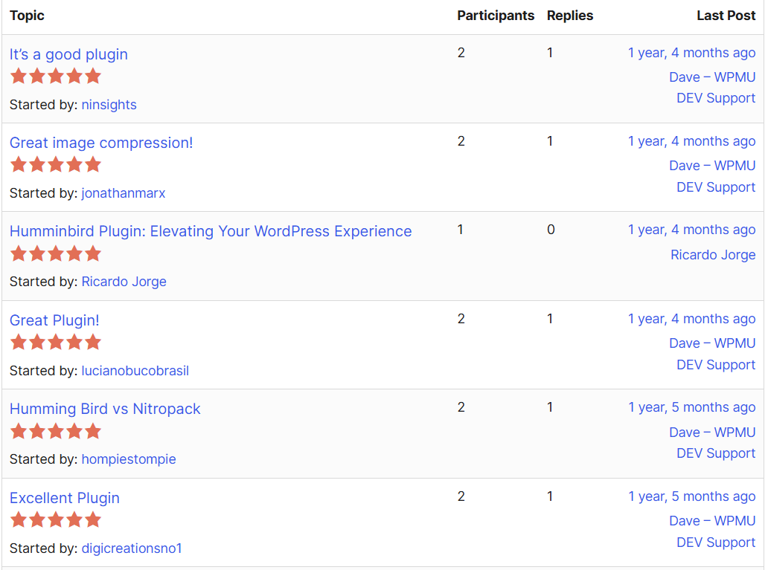

7. WPMU DEV forums

**[Hummingbird Pro] Hummingbird is causing a conflict with Divi builder**

When editing some pages with the Divi builder, the margins are very different. When saving and exiting Divi builder they look fine again. The users don’t understand how they can work around this, so I really would like to fix it.

example page: [**https://studiokluif.nl/about/**](https://studiokluif.nl/about/)

I have followed this article to try and fix it, but didn’t do the trick: [**https://divimode.com/set-up-divi-for-hummingbird/**](https://divimode.com/set-up-divi-for-hummingbird/)

I have disabled all Divi caching options. Cleared hummingbirds cache. Tried in Hummingbird to exclude all divi related files. Cleared hummingbirds cache. Disabled page caching. Cleared hummingbirds cache. Disabled generate critical css. Turned from speedy to basic optimization and cdn. Cleared hummingbirds cache.  
When I disable the complete plugin, the problem is solved. But the website is heavy and it needs a good caching system.

Is this something you can help me with?

Thank you.

Jun 7, 2024 at 10:09 AM

[More Hummingbird Pro discussions](https://wpmudev.com/forums/tags/hummingbird-pro)

[Hummingbird Pro](https://wpmudev.com/project/wp-hummingbird/)

* + [**Skip To Replies**](https://wpmudev.com/forums/topic/hummingbird-pro-hummingbird-is-causing-a-conflict-with-divi-builder/#comments)
  + [**All: View all topics**](https://wpmudev.com/forums/forum/support/)

* + [**General WordPress: All Things General WordPress**](https://wpmudev.com/forums/forum/support/general/)

* + [**Plugins & Themes: Plugin and Theme Support**](https://wpmudev.com/forums/forum/support/plugin-support/)

* + [**Multisite: All things WordPress Multisite**](https://wpmudev.com/forums/forum/support/multi-db-support/)

* + [**Features & Feedback: What can we develop for you?**](https://wpmudev.com/forums/forum/support/feature-suggestions/)

* + [**The Hub: All things WPMU DEV Hub! Automate, Reports, etc.**](https://wpmudev.com/forums/forum/support/the-hub/)

* + [**Hosting: Hosting Support**](https://wpmudev.com/forums/forum/support/wpmudev-hosting/)

* + [**Pro Email: WPMU DEV Pro Email Support**](https://wpmudev.com/forums/forum/support/pro-email/)

* + [**Services: WPMU DEV Services Support**](https://wpmudev.com/forums/forum/support/services/)

* + **Support Forum**
  + [User Gravatar](https://wpmudev.com/profile/adamczajczyk)

[**Adam Czajczyk**](https://wpmudev.com/profile/adamczajczyk)

* + Support Gorilla
  + [7,320 pts: Hero points](https://wpmudev.com/claim-your-wpmudev-membership/) [37,481 pts: Rep. points](https://wpmudev.com/claim-your-wpmudev-membership/) [LEVEL 30](https://wpmudev.com/claim-your-wpmudev-membership/)

Hi [**Jessy**](https://wpmudev.com/profile/jessy28877)

I hope you’re well today and I apologize for late response!

I tried disabling Hummingbird to see the issue but on that example page I didn’t really notice any difference between how the page looks

– with- and without Hummingbird plugin enabled  
– vs how it looks in Divi builder editor

I’m sure I’m missing something here (mainly due to the fact that I don’t know the site yet) but we could use a bit more help here:

1. could you provide some example screenshots of “good” and “bad” version so we’d know what exactly to look for and for what should we pay more attention?

2. and how can we “step by step” replicate this from scratch (let’s say I’d like to create a new page)?

Please advise!

Best regards,  
Adam

[Jun 7, 2024 at 3:28 PM: direct link to comment](https://wpmudev.com/forums/topic/hummingbird-pro-hummingbird-is-causing-a-conflict-with-divi-builder/#post-4406090)

* + [User Gravatar](https://wpmudev.com/profile/jessy28877)

[**Jessy**](https://wpmudev.com/profile/jessy28877)

* + Flash Drive
  + [164 pts: Hero points](https://wpmudev.com/claim-your-wpmudev-membership/) [31 pts: Rep. points](https://wpmudev.com/claim-your-wpmudev-membership/) [LEVEL 2](https://wpmudev.com/claim-your-wpmudev-membership/)

Hi Adam, the margins/width is different from that how it should be.  
I have made two recordings, 1 wich is not good and 1 where hummingbird is turned of and it is how it should be.

not good: [**https://www.loom.com/share/98e150e38f844dd5bdb2f803138a1959?sid=875419da-40c2-4a60-b930-8a8320300e4d**](https://www.loom.com/share/98e150e38f844dd5bdb2f803138a1959?sid=875419da-40c2-4a60-b930-8a8320300e4d)

good: [**https://www.loom.com/share/47d2879ca1a14f0cb91cf85a0fd8183c?sid=146d9fa9-4506-4884-91c9-8631cf99f47b**](https://www.loom.com/share/47d2879ca1a14f0cb91cf85a0fd8183c?sid=146d9fa9-4506-4884-91c9-8631cf99f47b)

Please let me know if you need antyhing else.  
Thank you.

[Jun 9, 2024 at 5:44 PM: direct link to comment](https://wpmudev.com/forums/topic/hummingbird-pro-hummingbird-is-causing-a-conflict-with-divi-builder/#post-4406711)

* + [User Gravatar](https://wpmudev.com/profile/adamczajczyk)

[**Adam Czajczyk**](https://wpmudev.com/profile/adamczajczyk)

* + Support Gorilla
  + [7,320 pts: Hero points](https://wpmudev.com/claim-your-wpmudev-membership/) [37,481 pts: Rep. points](https://wpmudev.com/claim-your-wpmudev-membership/) [LEVEL 30](https://wpmudev.com/claim-your-wpmudev-membership/)

Hi [**Jessy**](https://wpmudev.com/profile/jessy28877)

Thank you for response, now I can see it too!

Since it’s a live site I didn’t do any changes there yet but there’s one more thing that I’d like to test (you did not mention it in your initial post):

– instead of disabling Hummingbird entirely, please go to “Hummingbird -> Asset Optimization -> Settings” page and from there use “Deactivate” option to disable Asset Optimization  
– then purge all cache and test again

It looks to me like this issue is caused by some sort of unexpected conflict or glitch related to the fact that even in Divi editor – since it is front-end – Hummigbird still loads some assets in optimized versions. But we’d need to confirm that.

So if that issue doesn’t happen with Hummingbird still enabled but its Asset Optmization disabled, we’ll know where the culprit is and we’ll look for a way to overcome it (I’ve already asked our developers for suggestions if there’d be a way to force loading unoptimized assets in editor only).

If it still happens, we’d be able to rule it out at least.

Would you give it a go and let us know about results, please?

Kind regards,  
Adam

[Jun 10, 2024 at 5:07 PM: direct link to comment](https://wpmudev.com/forums/topic/hummingbird-pro-hummingbird-is-causing-a-conflict-with-divi-builder/#post-4407058)

* + [User Gravatar](https://wpmudev.com/profile/jessy28877)

[**Jessy**](https://wpmudev.com/profile/jessy28877)

* + Flash Drive
  + [164 pts: Hero points](https://wpmudev.com/claim-your-wpmudev-membership/) [31 pts: Rep. points](https://wpmudev.com/claim-your-wpmudev-membership/) [LEVEL 2](https://wpmudev.com/claim-your-wpmudev-membership/)

Hi Adam, thank you.  
I just deactivated it and then the problem is gone. And after activating it again, it takes a while, but then it’s back again.  
As you expected.

What is the best course of action for me right now?

Thanks again.

[Jun 11, 2024 at 10:09 AM: direct link to comment](https://wpmudev.com/forums/topic/hummingbird-pro-hummingbird-is-causing-a-conflict-with-divi-builder/#post-4407449)

* + [User Gravatar](https://wpmudev.com/profile/adamczajczyk)

[**Adam Czajczyk**](https://wpmudev.com/profile/adamczajczyk)

* + Support Gorilla
  + [7,320 pts: Hero points](https://wpmudev.com/claim-your-wpmudev-membership/) [37,481 pts: Rep. points](https://wpmudev.com/claim-your-wpmudev-membership/) [LEVEL 30](https://wpmudev.com/claim-your-wpmudev-membership/)

Hi [**Jessy**](https://wpmudev.com/profile/jessy28877)

Thanks for testing and response!

So just to makes sure – if you keep plugin active but only disable Asset Optimization, the issue is gone, right?

That’s a step forward then.

I asked you to test this because when I was checking the site I noticed that some assets are still being loaded in their optimized (as in Asset Optimization of Hummingbird) state and that actually shouldn’t be happening.

I actually tried to replicate this behavior with Divi and Hummingbird on my own setup (with my own created from scratch content, no other plugins and a different host) and I wasn’t able to and I was a bit surprised seeing that happening on your site.

I’m not yet sure why it is happening there. Normally I would suspect some additional caching but I don’t see any caching plugins other than Hummingbird on site, unless there is some sort or cache happening on server.

Anyway, let’s see if we can tackle that easily. Could you try again with Hummingbird and Asset Optimization enabled but also with this additional code added to the site as a Must Use plugin?

<?php

add_action('wp_enqueue_scripts', 'dbc_enqueue_non_visual_builder_scripts');

function dbc_enqueue_non_visual_builder_scripts() {

if (!empty($_GET['et_fb'])) {

add_filter( 'wp_hummingbird_is_active_module_minify', '__return_false', 99 );

}

}

To add code to the site:

– create an empty file with a .php extension (e.g. “hb-avoid-minify-in-divi-builder.php”) in the “/wp-content/mu-plugins” folder of your site’s WP install

– copy above code and paste it into that file

– save the file

– purge all caches.

Then re-enable Hummingbird and its Asset Optimization and wait until it “kicks in” and check if the issue is still happening.

What that code is supposed to do is to bypass/skip Asset Optimization on the page if it detects that the Divi’s visual builder is currently active – so it wouldn’t affect normal site performance and for regular visitors assets would still be optimized; it would only bypass serving them inside Divi’s visual builder.

Let’s see if that solves the issue for you.

Best regards,  
Adam

[Jun 11, 2024 at 4:26 PM: direct link to comment](https://wpmudev.com/forums/topic/hummingbird-pro-hummingbird-is-causing-a-conflict-with-divi-builder/#post-4407610)

* + [User Gravatar](https://wpmudev.com/profile/jessy28877)

[**Jessy**](https://wpmudev.com/profile/jessy28877)

* + Flash Drive
  + [164 pts: Hero points](https://wpmudev.com/claim-your-wpmudev-membership/) [31 pts: Rep. points](https://wpmudev.com/claim-your-wpmudev-membership/) [LEVEL 2](https://wpmudev.com/claim-your-wpmudev-membership/)

Hi Adam, thank you again.  
I have created the mu plugin, but it doesn’t look like it’s working.  
I deactivated the asset optimization after creating it and emptied the cache, but the problem is back again.

I did have a problem with a mu plugin before, it wasn’t executed. I don’t know anymore if this was on the same website and what kind of work around we used.  
Can I maybe try it as a php snippet in a snippet code plugin?

[Jun 12, 2024 at 12:35 PM: direct link to comment](https://wpmudev.com/forums/topic/hummingbird-pro-hummingbird-is-causing-a-conflict-with-divi-builder/#post-4408066)

* + [User Gravatar](https://wpmudev.com/profile/adamczajczyk)

[**Adam Czajczyk**](https://wpmudev.com/profile/adamczajczyk)

* + Support Gorilla
  + [7,320 pts: Hero points](https://wpmudev.com/claim-your-wpmudev-membership/) [37,481 pts: Rep. points](https://wpmudev.com/claim-your-wpmudev-membership/) [LEVEL 30](https://wpmudev.com/claim-your-wpmudev-membership/)

Hi [**Jessy**](https://wpmudev.com/profile/jessy28877)

*I deactivated the asset optimization after creating it and emptied the cache, but the problem is back again.*

Hm…wait a sec! Maybe I misunderstood something earlier. You have deactivated Asset Optimization, kept it inactive and yet the issue is still happening with Asset Optimization disabled?

I was under impression earlier under the last test, that disabling Asset Optimzation fixes it but if it does not then this shared code also would make no sense as a fix.

Or have you:  
– added the mu plugin  
– deactivated Asset Optimization  
– cleared cache  
– and activated Asset Optimization again?

I’m sorry, I’m just a bit confused and it’s important for us to be on the same side here.

*Can I maybe try it as a php snippet in a snippet code plugin?*

Yes, you can try it if you have some snippet plugin that supports PHP code.

—–

With that all being said:

– if (regardless of the MU plugin) the issue actually goes away if Asset Optimization is disabled  
– AND adding MU plugin code – via a file or a snippet still doesn’t fix that

I’d need to include our developers in the case but for that we’d need direct access to site – both site’s back-end and files on server (via FTP or similar way). But let’s first sort our above so do not post any credentials here. If adding code via snippet doesn’t solve that – update us here and we’ll provide you with a secure way to send us necessary access crednetials.

Best regards,  
Adam

[Jun 12, 2024 at 1:31 PM: direct link to comment](https://wpmudev.com/forums/topic/hummingbird-pro-hummingbird-is-causing-a-conflict-with-divi-builder/#post-4408086)

* + [User Gravatar](https://wpmudev.com/profile/jessy28877)

[**Jessy**](https://wpmudev.com/profile/jessy28877)

* + Flash Drive
  + [164 pts: Hero points](https://wpmudev.com/claim-your-wpmudev-membership/) [31 pts: Rep. points](https://wpmudev.com/claim-your-wpmudev-membership/) [LEVEL 2](https://wpmudev.com/claim-your-wpmudev-membership/)

Hi Adam, I forgot to mention I activated the asset optimization again and then the problem returned.

So now I have installed the php snippet, deactivated the asset optimization, cleared cache: result: problem gone.  
After this I turned asset optimization back on and cleared cache. result: problem back.  
So even though the php snippet is activated, it’s not working.

So I will give you the credentials as asked.

[Jun 13, 2024 at 11:56 AM: direct link to comment](https://wpmudev.com/forums/topic/hummingbird-pro-hummingbird-is-causing-a-conflict-with-divi-builder/#post-4408505)

* + [User Gravatar](https://wpmudev.com/profile/vikramsingh91683)

[**Vikram Singh**](https://wpmudev.com/profile/vikramsingh91683)

* + Staff
  + [341 pts: Hero points](https://wpmudev.com/claim-your-wpmudev-membership/) [7,584 pts: Rep. points](https://wpmudev.com/claim-your-wpmudev-membership/) [LEVEL 25](https://wpmudev.com/claim-your-wpmudev-membership/)

Hi [**Jessy**](https://wpmudev.com/profile/jessy28877)  ,

We need to investigate the issue further and it requires your FTP/Cpanel + WP-Admin access.

I have enabled a secure contact form “**DIRECT CONTACT FORM**” for you that you can find on the right sidebar of this page. Please send us your login details using this form.

You can find detailed information about it here:  
[**https://wpmudev.com/docs/getting-started/getting-support/#support-tickets-additional-details**](https://wpmudev.com/docs/getting-started/getting-support/#support-tickets-additional-details)

**Note**: Please **DO NOT** share any log in details in the reply to this ticket.

Best Regards,  
Vikram Singh

[Jun 13, 2024 at 1:27 PM: direct link to comment](https://wpmudev.com/forums/topic/hummingbird-pro-hummingbird-is-causing-a-conflict-with-divi-builder/#post-4408529)

* + [User Gravatar](https://wpmudev.com/profile/jessy28877)

[**Jessy**](https://wpmudev.com/profile/jessy28877)

* + Flash Drive
  + [164 pts: Hero points](https://wpmudev.com/claim-your-wpmudev-membership/) [31 pts: Rep. points](https://wpmudev.com/claim-your-wpmudev-membership/) [LEVEL 2](https://wpmudev.com/claim-your-wpmudev-membership/)

Additional details sent (automated message)

[Jun 13, 2024 at 1:46 PM: direct link to comment](https://wpmudev.com/forums/topic/hummingbird-pro-hummingbird-is-causing-a-conflict-with-divi-builder/#post-4408541)

* + [User Gravatar](https://wpmudev.com/profile/patrick.freitas)

[**Patrick Freitas**](https://wpmudev.com/profile/patrick.freitas)

* + FLS
  + [4,472 pts: Hero points](https://wpmudev.com/claim-your-wpmudev-membership/) [25,230 pts: Rep. points](https://wpmudev.com/claim-your-wpmudev-membership/) [LEVEL 30](https://wpmudev.com/claim-your-wpmudev-membership/)

Hi [**Jessy**](https://wpmudev.com/profile/jessy28877)

Thank you,

I see the code was added using a PHP Snippet plugin plus mu-plugin, I kept just as mu-plugin as this is the correct approach.

Can you please check your website now?

The only difference was:

– Switched to Font swap instead of preload font  
– Switched the Critical CSS to Above of fold, this is playing better with your site because of the GIF.  
– Enabled Divi > Builder > Inline CSS which helps with some style problems as the CSS is added to source code directly.

I also made sure to test with all the options enabled:

*[attachments are only viewable by logged-in members]*

Front end incognito, no script errors:

*[attachments are only viewable by logged-in members]*

The builder looks good too:

*[attachments are only viewable by logged-in members]*

That page is also getting a great score even when testing from an Asia network ( As Google simulate your local network for the result so closer to the server location you tend to get a better score )

*[attachments are only viewable by logged-in members]*

Let us know if you have any additional questions.  
Best Regards  
Patrick Freitas

[Jun 14, 2024 at 2:36 AM: direct link to comment](https://wpmudev.com/forums/topic/hummingbird-pro-hummingbird-is-causing-a-conflict-with-divi-builder/#post-4408838)

* + [User Gravatar](https://wpmudev.com/profile/jessy28877)

[**Jessy**](https://wpmudev.com/profile/jessy28877)

* + Flash Drive
  + [164 pts: Hero points](https://wpmudev.com/claim-your-wpmudev-membership/) [31 pts: Rep. points](https://wpmudev.com/claim-your-wpmudev-membership/) [LEVEL 2](https://wpmudev.com/claim-your-wpmudev-membership/)

Thank you Patrick, this looks very good indeed.  
Thank you for finding the right settings, would not have been able to find this on my own. I’m happy!

[Jun 16, 2024 at 2:53 PM: direct link to comment](https://wpmudev.com/forums/topic/hummingbird-pro-hummingbird-is-causing-a-conflict-with-divi-builder/#post-4409551)

# Market research

* 1. W3 Tech

[Technologies](https://w3techs.com/technologies) > Content Management

**Usage statistics and market shares of content management systems**

Request an **extensive content management systems market report**.  
  
[Learn more](https://w3techs.com/technologies/reportlist/content_management)

This diagram shows the percentages of websites using various content management systems. See [technologies overview](https://w3techs.com/technologies) for explanations on the methodologies used in the surveys. Our reports are updated daily.

How to read the diagram:  
28.6% of the websites use none of the content management systems that we monitor.  
WordPress is used by 43.4% of all the websites, that is a content management system market share of 60.8%.

Perfect — this is exactly what you need for your **light market research section**. Here’s how to write it up cleanly in your report or slide:

**🌐 CMS Market Share Snapshot (as of August 2025)**

* **WordPress powers 43.4% of all websites globally**, making it the most widely used CMS on the web.
* Among websites using a CMS, **WordPress holds a 60.8% market share**.
* Only 28.6% of websites use no content management system at all.

📊 *Source: W3Techs CMS Usage Statistics*

You can now use this to:

* Justify why optimizing for WordPress users (via tools like Hummingbird) has massive market potential.
* Position Hummingbird’s impact in the broader CMS ecosystem.
* Anchor any “Target Market” slides with actual adoption data.

Let me know if you'd like help converting this into a chart or slide visual.

* 1. Statista

1. **Website builders market share worldwide 2024**
2. Published by
3. [Lionel Sujay Vailshery](https://www.statista.com/aboutus/our-research-commitment/2816/lionel-sujay-vailshery)
4. 
5. ,
6. Jul 1, 2025
7. As of 2024, WordPress.org is the leading website builder in the world, accounting for over 68 percent of global market share. Wix and Squarespace ranked as the second and third most popular website building platforms, each of which accounted for 13 and 8.5 percent respectively of market share.
8. **Website builders**
9. Website building tools such as Wix and Squarespace allow for users to construct and manage customizable websites without the need for advanced coding knowledge. These platforms often include customizable design templates and offer extensions for e-commerce and mailing lists. Although Wix has the biggest worldwide market share, Weebly and Squarespace rank as the [most popular platforms in the United States](https://www.statista.com/statistics/818633/website-builders-market-share-united-states/). As the functionality offered by these platforms increases, so too does the market’s overall revenue figure. Between 2012 and 2017 [website builder revenue](https://www.statista.com/statistics/818604/website-builders-sales-worldwide/) increased from around one billion U.S. dollars to over 1.5 billion dollars. As overall [web traffic](https://www.statista.com/statistics/267203/consumer-internet-traffic-through-e-mail-web-and-data-usage-in-north-america/) and global internet access continue to rise, it has become increasingly important for businesses to have an online site for sales, marketing, and general contact information. These website building tools allow businesses of all sizes to maintain an online presence without having to spend huge sums of money on web design or coding.